MODULE V
Applications -WWW, E-mail, Name Service, Network Management, Web Services, Custom Application protocol, Generic Application Protocol, Overlay Networks-Peer to Peer Networks.
ELCTRONIC MAIL (SMTP, MIME, IMAP)
Discuss the components of an e-mail system and protocols used
- The e-mail system involved in Alice sending a message to Bob is shown.

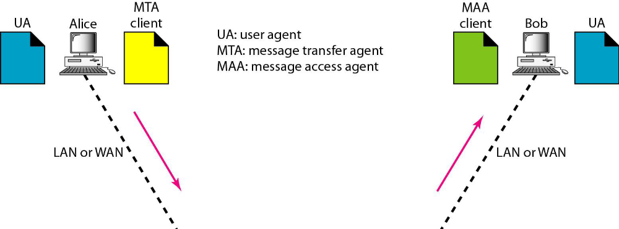
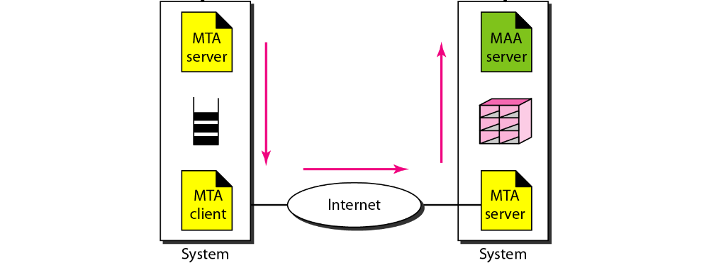User Agent
- A user agent (UA) is software that is either command (eg. pine, elm) or GUI based (eg. Microsoft Outlook, Netscape). It facilitates:
  - Compose : Helps to compose messages by providing template with built-in editor
  - Read: Checks mail in the incoming box and provides information such as sender, size, subject and flag (read, new).
  - Reply: Allows user to reply (send message) back to sender
  - Forward: Facilitates forwarding message to a third party
  - Mailboxes: Creates two mailboxes for each user, namely inbox (to store received
emails) and outbox (to keep all sent mails)
Message Format
- RFC822 defines message to have two parts namely header and a body.
- The message header is a series of <CRLF> terminated lines. Each header line contains a
type and value separated by a colon (:). It is filled by the user/system. Some of them are:
- From: User who sent the message
- To: Identifies the message recipient(s).
- Subject: Says something about the purpose of the message
- Date: When the message was transmitted
- E-mail address consists of user_name@domain_name where domain_name is hostname of the mail server.
- The body of the message contains the actual information
- The header is separated from the message body by a blank line.
- Initially email system was designed to send messages only in NVT 7-bit ASCII format.
- Languages such as French, German, Chinese, Japanese were not supported.
- Image, audio and video files cannot be sent.
Multipurpose Internet Mail Extensions (MIME)

- MIME is a supplementary protocol that allows non-ASCII data to be sent through e-mail
- MIME transforms non-ASCII data to NVT ASCII and delivers to client MTA. The NVT ASCII data is converted back to non-ASCII form at the recipient mail server.
- MIME defines five headers. They are:
  - MIME-Version: Specifies the current version 1.1
  - Content-Type: Specifies message type such as text (plain, html), image (jpeg, gif), audio, video and application (postscript, msword). If more than one type exists, then it is termed as multipart (mixed).
  - Content-Transfer-Encoding: Defines how data in the message body is encoded such as binary, base64, 7-bit, etc.
  - Content-Id: Unique identifier the whole message in a multiple message type.
  - Content-Description: Describes type of the message body.
Example
MIME-Version: 1.0
Content-Type: multipart/mixed; boundary="-------417CA6E2DE4ABCAFBC5"
From: Alice Smith <Alice@cisco.com>
To: Bob@cs.Princeton.edu
Subject: promised material
Date: Mon, 07 Sep 1998 19:45:19 -0400
---------417CA6E2DE4ABCAFBC5
Content-Type: text/plain; charset=us-ascii
Content-Transfer-Encoding: 7bit
…
---------417CA6E2DE4ABCAFBC5
Content-Type: image/jpeg
Content-Transfer-Encoding: base64
Message Transfer Agent (MTA): SMTP
- Message Transfer Agent (MTA) is a mail daemon that helps to transmit/receive message over the network.
- To send mail a system must have the client MTA, and to receive mail a system must have a server MTA.
- Simple Mail Transfer Protocol (SMTP) defines communication between client/server MTA.
- SMTP uses TCP connection on port 25 to forward the entire message and store at intermediate mail servers/mail gateways until it reaches the recipient mail server.
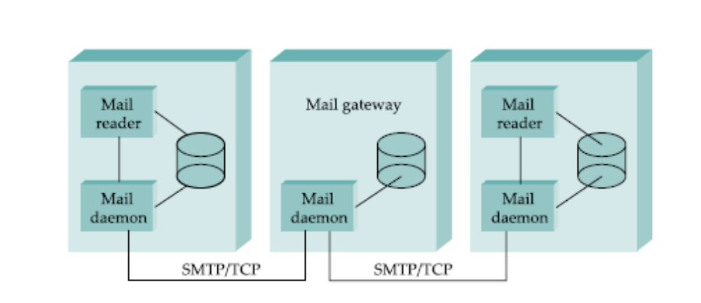
- SMTP defines how commands and responses must be sent back and forth.
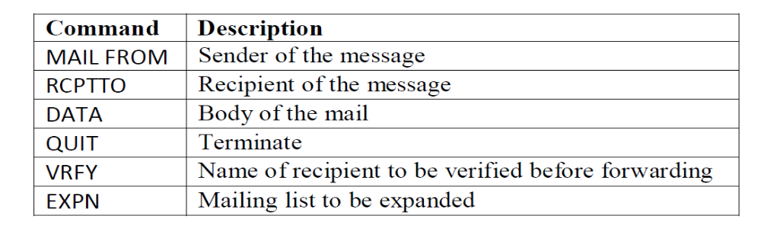
- Common responses sent from server MTA are:
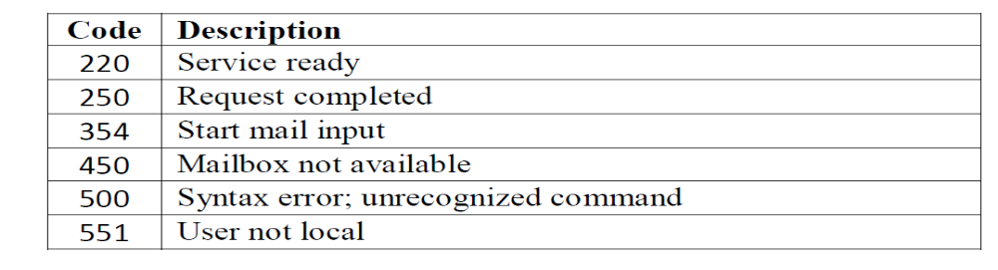
Example
HELO cs.princeton.edu
250 Hello daemon@mail.cs.princeton.edu [128.12.169.24]
MAIL FROM:<Bob@cs.princeton.edu>
250 OK
RCPT TO:<Alice@cisco.com>
250 OK
DATA
354 Start mail input; end with <CRLF>.<CRLF>
Blah blah blah...
...etc. etc. etc.
<CRLF>.<CRLF>
250 OK
QUIT
221 Closing connection
- In each exchange, the client posts a command and the server responds with a code. and a human-readable explanation for the code.
- After the commands and responses, client sends the message which is ended by a period (.) and terminates the connection.
Message Access Agent (MAA)/Mail Reader: POP and IMAP
- MAA or mail reader allows user to retrieve messages from the mailbox, so that user can perform actions such as reply, forwarding, etc.
- The two message access protocols are:
  - Post Office Protocol, version 3 (POP3)
  - Internet Mail Access Protocol, version 4 (IMAP4)
- SMTP is a push type protocol whereas POP3 and IMAP4 are pop type protocol.
POP3
- POP3 is simple and limited in functionality
- POP3 works in two modes namely, delete and keep mode.
  - In delete mode, mail is deleted from the mailbox after retrieval
  - In keep mode, mail after reading is kept in mailbox for later retrieval.
- POP3 client is installed on the recipient computer and POP3 server on the mail server.
- The client opens a connection to the server on TCP port 110.
- The client sends username and password to access the mailbox and retrieve the messages.
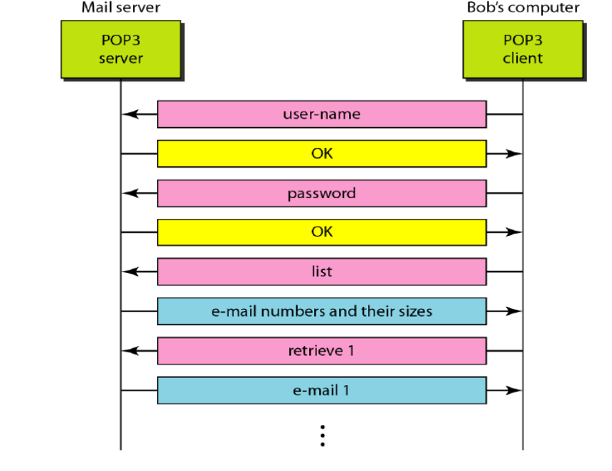
IMAP4
- IMAP is a client/server protocol running over TCP. The client issues commands and the mail server responds.
- The exchange begins with the client authenticating itself to access the mailbox.
- When the user asks to FETCH a message, server returns it in MIME format and the mail reader decodes it.
- IMAP also defines message attributes such as size and flags such as Seen, Answered, Deleted and Recent.
Why is POP not preferred?
- It does not allow the user to organize their mail on the server
- The user cannot have different folders on the server
- It does not allow the user to partially check the contents of the mail before downloading
List the advantages of IMAP over POP
- IMAP4 is more powerful and more complex than POP3. The additional features are:
- A user can check the e-mail header prior to downloading.
- A user can search e-mail for a specific string of characters prior to downloading.
- A user can partially download e-mail. This is especially useful if bandwidth is limited and the e-mail contains multimedia with high bandwidth requirements.
- A user can create, delete, or rename mailboxes on the mail server.
- A user can create a hierarchy of mailboxes in a folder for e-mail storage.

WORLD WIDE WEB
Explain HTTP protocol in detail.
- WWW is a distributed client/server service, in which a client (web browser) can access a service through a server, where the service is distributed over many locations called sites.
- Web browsers allow users to access files using uniform resource locator (URL).
- When user enters URL, the browser forms a request message and sends to the server.
- The server retrieves the requested URL and sends it as a response message. The browser displays the response in HTML / appropriate format.
- HTTP is a stateless request/response protocol that governs client/server communication.
- HTTP uses TCP connection on port 80 to transfer data between client and server.
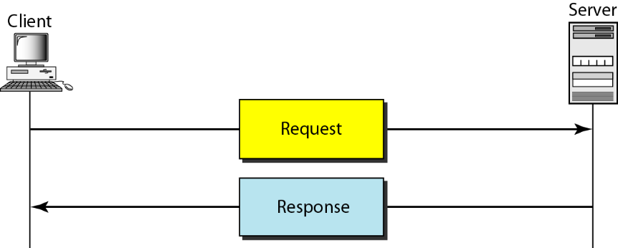
- Message Format
START_LINE <CRLF>
MESSAGE_HEADER <CRLF>
<CRLF>
MESSAGE_BODY <CRLF>
- Request Message
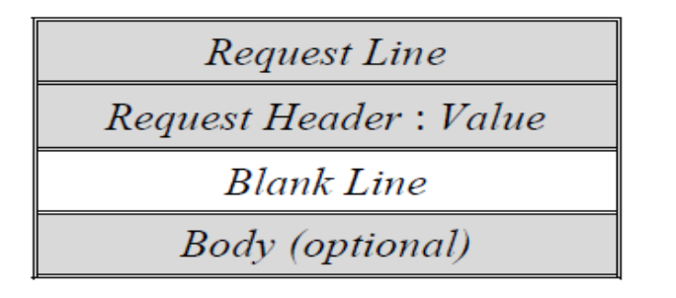
Request Line
- The Request line contains three fields as shown.
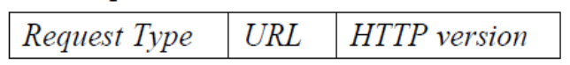
- HTTP version specifies current version of the protocol i.e., 1.1
- The Request type specifies methods that operate on the URL. The methods are:
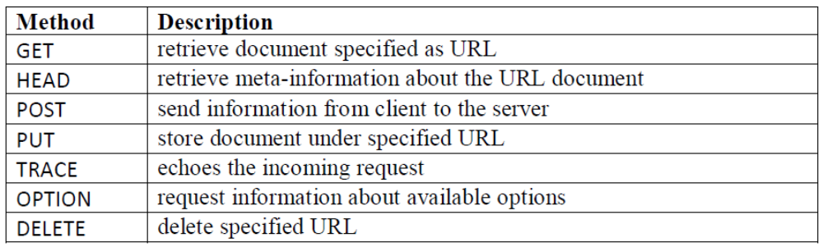
- For example, the request line to retrieve file index.html on host cs.princeton.edu is
GET http://www.cs.princeton.edu/index.html HTTP/1.1
Request Header

- Request Header specifies client's configuration and preferred document format:
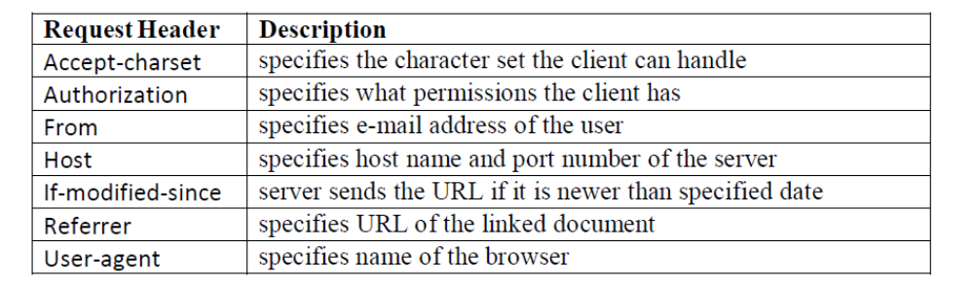
- The above example using request header is specified as
GET index.html HTTP/1.1
Host: www.cs.princeton.edu
Response Messages
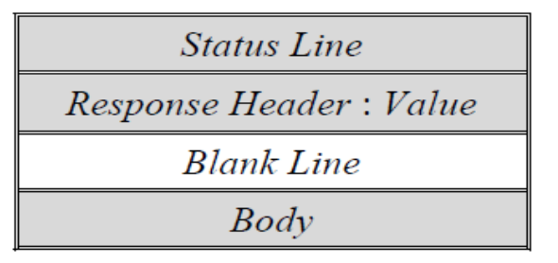
- Status line
  - The Status line contains three fields as shown.
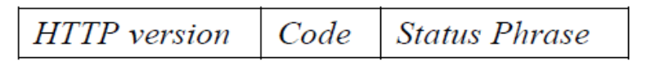
- The status code field consists of three digits (1xx–Informational, 2xx–Success, 3xx–Redirection, 4xx–Client Error, 5xx–Server Error)
- The status phrase explains the status code in text form. Some of them are:

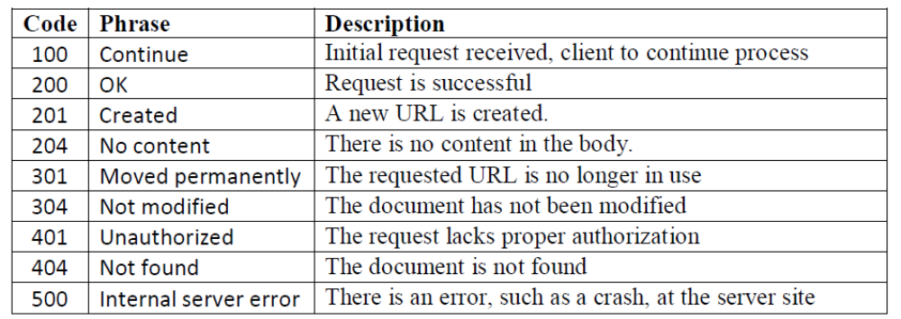
- For example, the server reports as follows, if the requested file is not found
HTTP/1.1 404 Not Found
Response Header
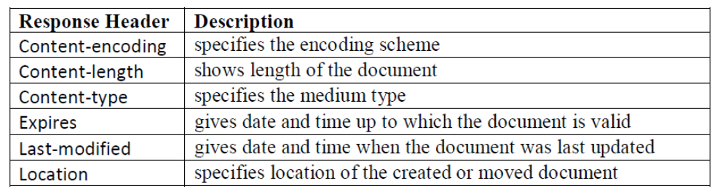
- The response for a moved page is given below.
HTTP/1.1 301 Moved Permanently
Location: http://www.princeton.edu/cs/index.html.
PERSISTENT VS NON-PERSISTENT CONNECTION
- In non-persistent, a TCP connection is required for each request/response
  - Imposes high overhead on the server because the server needs N buffers for N URL pointers and TCP overhead for each connection
- In persistent, Client and server can exchange multiple request/response messages over the same TCP connection
  - Eliminates the connection setup overhead and load on the server
  - TCP’s congestion window mechanism is able to operate more efficiently.
  - The server times out, if there is no request from the client for a specified period

CACHING
- Caching enables the client to retrieve document faster and reduces load on the server.
- Caching can be implemented at different places
  - For example, the ISP router can cache pages. Further such request coming from its clients, the ISP responds.
  - Proxy server is a host that keeps copies responses to recent requests. The client sends request to the proxy server. The proxy server either responds to client or forwards the request to the server.
  - The browser also can cache pages.
- Server assigns expiration date (using Expires header field) to each page, beyond which the page should not be cached.
- Therefore prior to caching a page, its expiration date is checked. If a cached page reaches its expiration, then the page is deleted.
- The proxy verifies whether it has the latest document by using If-Modified-Since header.
- A page must not be cached if no-cache directive is specified.
NAME SERVICE (DNS)
Explain the role of DNS on a computer network.
- Domain-names are easily remembered than IP address of a host, since it is user-friendly.
- Thus, need for a system to map domain name to an IP address that includes:
  - A namespace to define domain names without conflict.
  - Binding of domain names to IP address
  - A name server that returns IP address for a given name
- During early days of internet, there were only few hundred hosts
  - A central authority called the Network Information Center (NIC) maintained name-to-address bindings in a flat-file called hosts.txt
  - A new host that joins the internet would mail its name and IP address to NIC.
  - NIC updates hosts.txt and mails to all hosts.
  - Name server resolved domain names using a simple lookup on hosts.txt
- As hosts grew to thousands and millions, the flat file approach failed, leading to evolution of DNS in mid 1980s.
Name Hierarchy
- DNS uses hierarchical name space for domains in the Internet.
- Hierarchical naming permits use of same sub-domain name in different domains.
- Domain names are case insensitive and can be up to 63 characters
- DNS names are processed from right to left and use periods (.) as separator.
- DNS can be used to map names to values, not necessarily domain names to IP address.
- DNS hierarchy can be visualized as a tree, where each node in the tree corresponds to a domain and the leaves relate to hosts.
- Six big domains are .edu (education) .com (commercial) .gov (US government) .mil (US military) .org (non-profitable organization) and .net (network providers).
- Top level domain exist one for each country .fr (france) .in (india), etc.
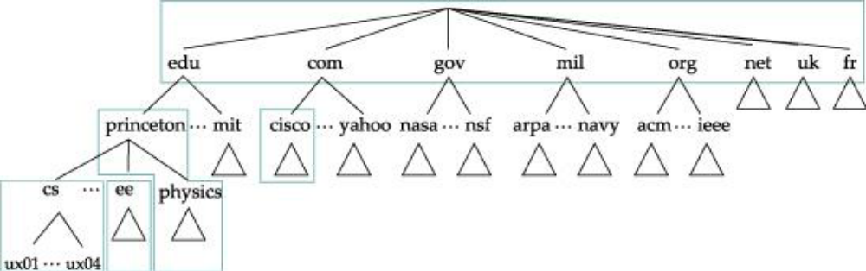

Name Servers

- The domain hierarchy is partitioned into zones. Topmost domains are managed by NIC.
- Each zone acts as central authority for that part of the sub-tree.
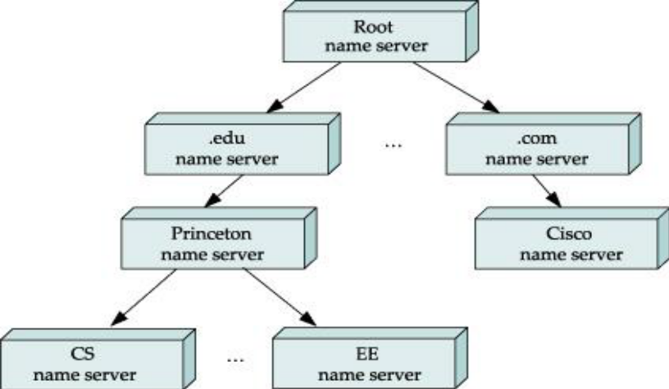
- In the .edu hierarchy, princeton is a zone.
  - Each zone can be further sub-divided that manage using their own name servers such as CS department under princeton university.
- Each zone information is implemented on at least two name servers.
- Clients send queries to name servers, and name servers respond to it.
- The response contains either the host IP address or address of another name server
- Each name server contains a collection of resource records.
  - A resource record is a name-to-value binding and is a 5-tuple with the following fields
- Name tells the domain to which this record applies. It is the primary search key, used to satisfy queries
- The Type field tells what kind of record it is. Some commonly used types are:
  - NS : Value field contains a name server
  - CNAME : Value field contains canonical name for the host. Used to define aliases.
  - MX: Value field contains a mail server that accepts messages for the domain.
  - A: Value field contains an IP address
- The Value field can be a number, a domain name, or an ASCII string. The semantics depend on the record type
- For internet information, the Class field is always IN.
- The TTL field gives an indication of how long the resource record is valid.
Name Resolution for cicada.cs.princeton.edu
1. The client first sends a query containing cicada.cs.princeton.edu to the root server.
2. The root server, does not finds an exact match, but locates the NS record for princeton.edu
3. The root returns the A record for princeton.edu back to the client.
4. The client sends the same query to 128.196.128.233 and receives the A record for cs.princeton.edu
5. Finally the client sends the query to 192.12.69.5 and gets the A record for cicada.cs.princeton.edu

Drawbacks
- All hosts should know the root name server, which is not feasible.
- Instead, the client can send query to the local name server that it knows
- The local name server can query the root name server on behalf of the client.
- Once the local NS gets the required response, it caches the A record based on TTL and sends the record to the client.
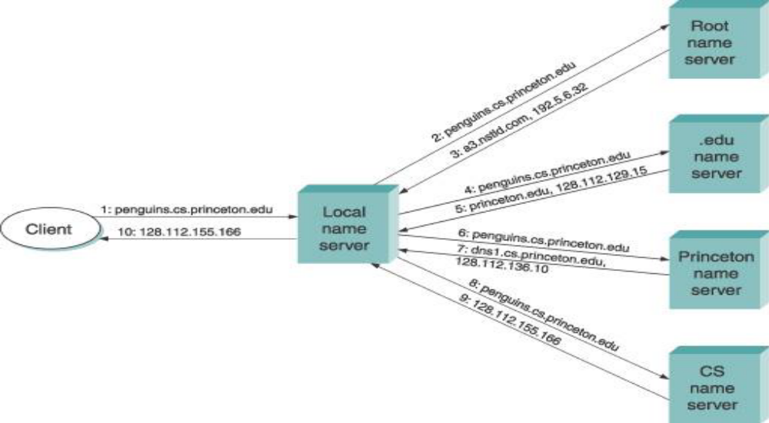
NETWORK MANAGEMENT (SNMP)
Explain how SNMP is used to manage nodes on the network.
- Simple Network Management Protocol (SNMP) is a framework for managing devices in an internet using TCP/IP.
- It provides a set of fundamental operations for monitoring and maintaining an internet
- SNMP uses the concept of manager and agent.
  - A manager is a host that runs the SNMP client program
  - A managed station called an agent, is a router that runs the SNMP server program
- SNMP is an application layer protocol; therefore it can monitor devices of different manufacturers installed on different physical networks.
- SNMP management includes:
  - A manager that checks an agent by requests information on behavior of the agent.
  - A manager forces an agent to perform a task by setting/resetting values in the agent database.
  - An agent warns the manager of an unusual situation.
- SNMP uses services of UDP on two well-known ports, 161 (agent) and 162 (manager).
- SNMP is supported by two other protocols in Internet Network management. They are:
  - Structure of Management Information (SMI)
  - Management Information Base (MIB)
- The role of SNMP is to
  - Define format of the packet to be sent from a manager to an agent and vice versa.
  - Interprets the result and creates statistics
  - Responsible for reading and setting object values
- The role of SMI is to
  - Define rules for naming objects and object types.
  - Uses Basic Encoding Rules to encode data to be transmitted over the network.
- The role of MIB is to
  - creates a collection of named objects, their types, and their relationships to each other in an entity to be managed
Object Identifier

- SMI uses an object identifier, which is a hierarchical identifier based on a tree structure
- The tree structure starts with an unnamed root.
- Each object can be defined by using a sequence of integers separated by dots.
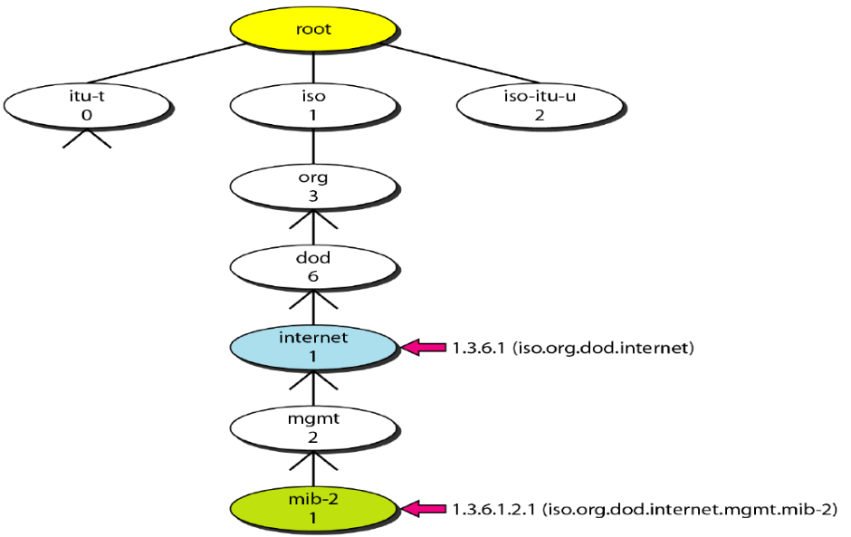
- The objects that are used in SNMP are located under the mib-2 object, so their identifiers always start with 1.3.6.1.2.1
- Object identifiers follow lexicographic ordering.
MIB Groups

- Each agent has its own MIB2 (version 2), which is a collection of all the objects that the
manager can manage.
- The objects in MIB2 are categorized under 10 different groups namely system, interface, address translation, ip, icmp, tcp, udp, egp, transmission, and snmp.
  - sys (system): defines general information about the node such as the name, location, and lifetime.
  - if (interface): defines information about all the interfaces of the node such as physical address and IP address, packets sent and received on each interface, etc.
  - at (address translation) : defines information about the ARP table
  - ip : defines information related to IP such as the routing table, statistics on datagram forwarding, reassembling and drop, etc.
  - tcp: defines general information related to TCP, such as the connection table, time-out value, number of ports, and number of packets sent and received.
  - udp: information on UDP traffic such as total number of UDP packets sent and received
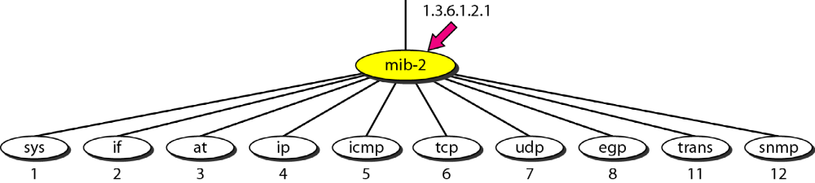

MIB Variables
MIB variables are of two types namely simple and table.
- To access any of the simple variable content, use id of the group (1.3.6.1.2.1.7) followed by the id of the variable and an instance suffix, which is 0.
  - For example, variable udpInDatagrams is accessed as 1.3.6.1.2.1.7.1.0
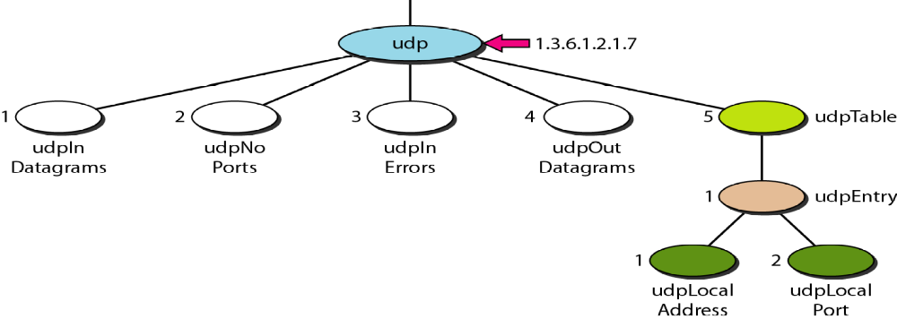
- In case of table, only leaf elements are accessible.
  - In this case, the group id is followed by table id and so on up to the leaf element.
  - To access a specific instance (row) of the table, add the index to the above ids.
  - The indexes are based on the value of one or more fields in the entries.
  - Tables are ordered according to column-row rules, i.e one should go column by column from top to bottom.
SNMPv3 PDU

- SNMP is request/reply protocol that defines PDUs GetRequest, GetNextRequest, GetBulkRequest, SetRequest, Response and Trap.
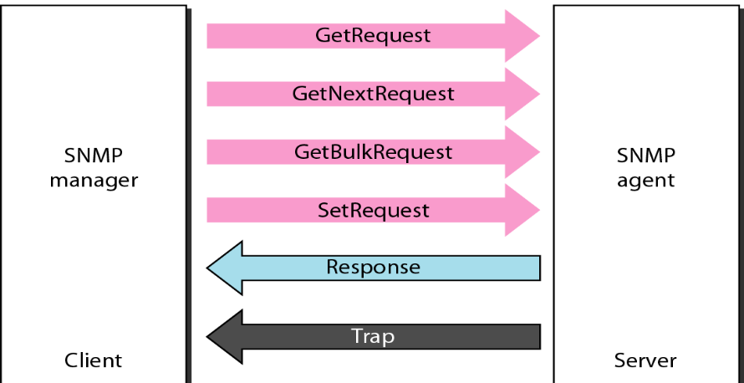

- GetRequest: used by manager to retrieve value of agent's variable(s)
- GetNextRequest: used by manager to retrieve next entries in a agent's table
- SetRequest: used by manager to set value of an agent's variable
- Response: sent from an agent to manager in response to GetRequest/ GetNextRequest that contains value of variables
- Trap: sent from an agent to the manager to report an event such as reboot.
PDU Format
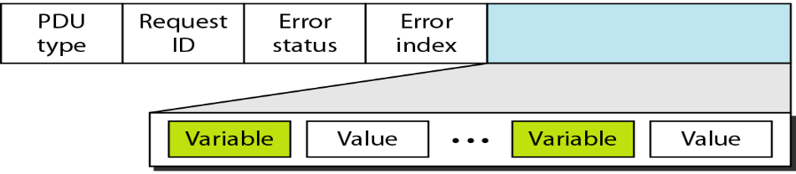
- The SNMP client puts the identifier for the MIB variable it wants to get into the request message, and sends this message to the server.
- The server then maps this identifier into a local variable, retrieves the current value held in this variable, and uses BER to encode the value it sends back to the client.

WEB SERVICES
- Direct application-to-application communication
- Two architectures
  - SOAP (Simple Object Access Protocol)
  - REST (Representational )

CUSTOM APPLICATION PROTOCOL (WSDL, SOAP)
- SOAP is based on Web Services Description Language (WSDL)

